**Advance Excel Assignment 5**

**1. How many types of conditions are available in conditional formatting on Excel?**

There are 5 types of conditional formatting visualizations available:

* Background Color Shading (of cells)
* Foreground Color Shading (of fonts)
* Data Bars
* Icons (which have 4 different image types)
* Values

**2. How to insert border in Excel with Format Cells dialog?**

To insert a border via the *Format Cells* dialog, this is what you need to do:

1. Select one or more cells to which you'd like to add borders.
2. Open the *Format Cells* dialog box by doing one of the following:
   * Click the down arrow next to the *Borders* button, and then click **More Borders** at the bottom of the drop-down list.
   * Right click the selected cells and choose *Format Cells…* from the context menu.
   * Press Ctrl+1 shortcut.

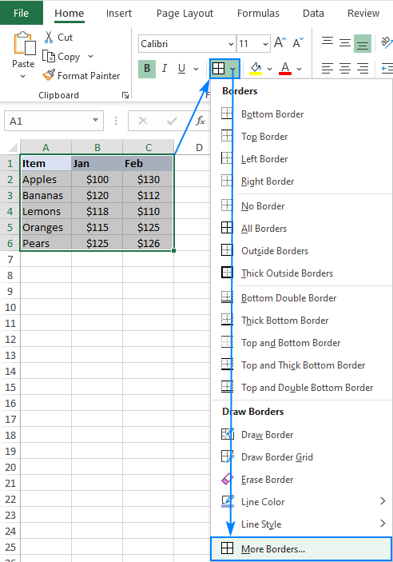

1. In the *Format Cells* dialog box, switch to the **Border** tab and choose the line style and color first. And then, either use *Presets* to add the outside or inside borders or construct the desired border by selecting individual elements such as border top, bottom, right or left. The preview diagram will reflect the changes immediately.
2. When done, click OK.  
   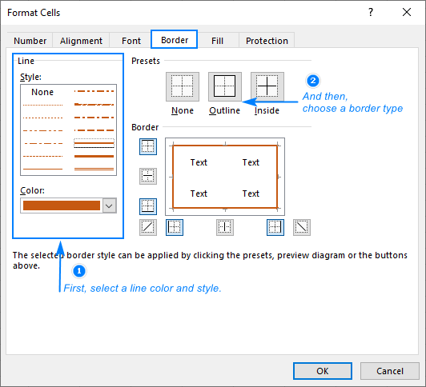

**3. How to Format Numbers as Currency in Excel?**

1. Select the cells that you want to format and then, in the **Number** group on the **Home** tab, click the down arrow in the **Number Format** box.
2. Choose either **Currency** or **Accounting**.

**4. What are the steps to format numbers in Excel with the Percent style?**

* On the **Home** tab, in the **Number** group, click the icon next to **Number** to display the **Format Cells** dialog box.
* In the**Format Cells** dialog box, in the **Category** list, click **Percentage**.
* In the Decimal places box, enter the number of decimal places that you want to display. For example, if you want to see 10% instead of 10.00%, enter 0 in the Decimal places box.

**5. What is a shortcut to merge two or more cells in excel?**

Shortcut to Merge Cells: ALT H+M+M.

**6. How do you use text commands in Excel?**

The **TEXT** function lets you change the way a number appears by applying formatting to it with **format codes**. It's useful in situations where you want to display numbers in a more readable format, or you want to combine numbers with text or symbols.